**Suggestions:-**

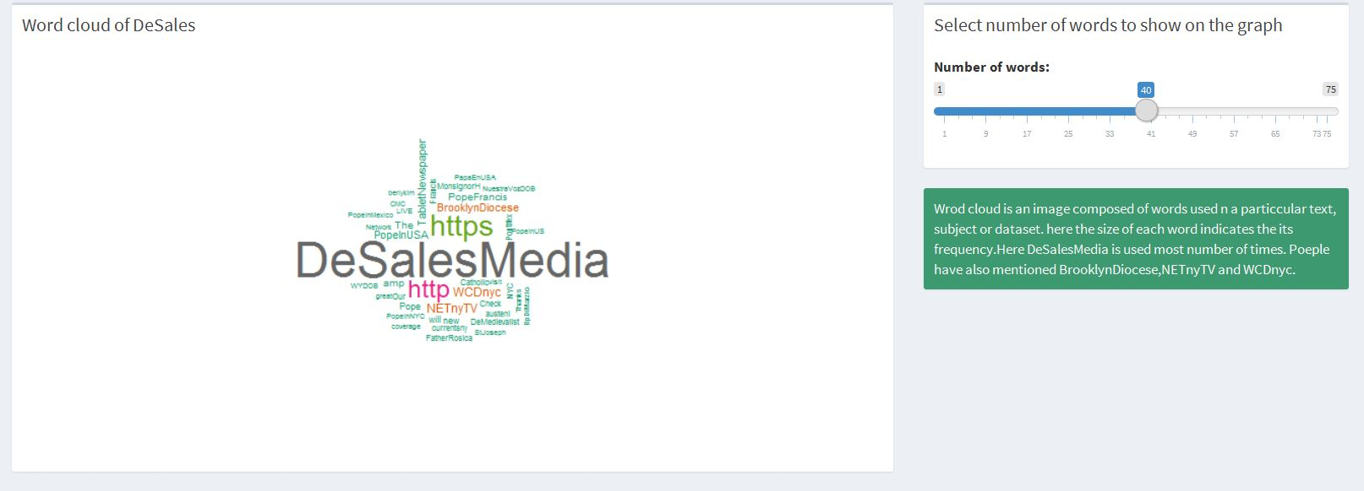

DeSales can use world cloud for the better performance of its NET TV cable network. Word cloud will help to find out the current affairs in the market which DeSales can broadcast on its cable network and attract more people towards it.

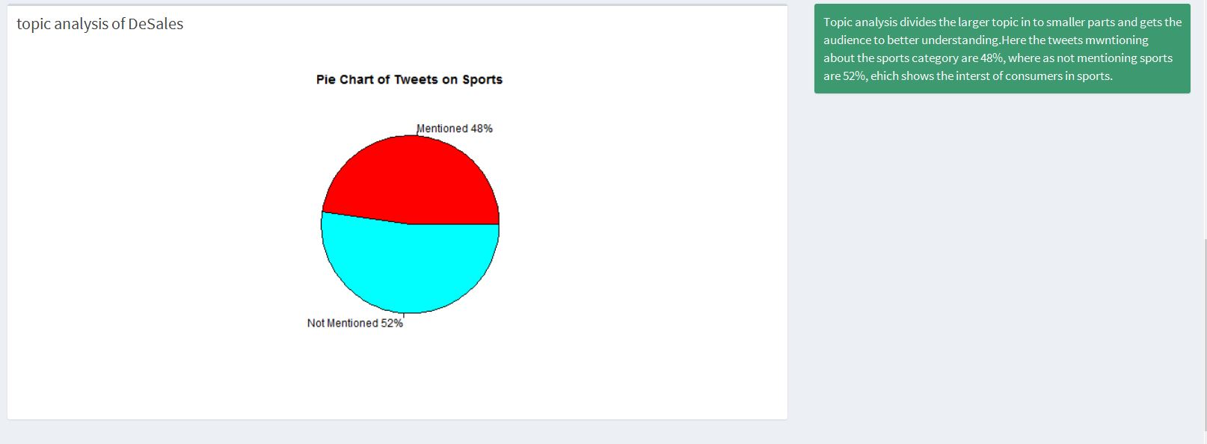

By using Topic Classification company can come to know about which topic people more talk about, so DeSales can focus on that particular topic. Also, DeSales would know people's opinions and suggestions to make things better.

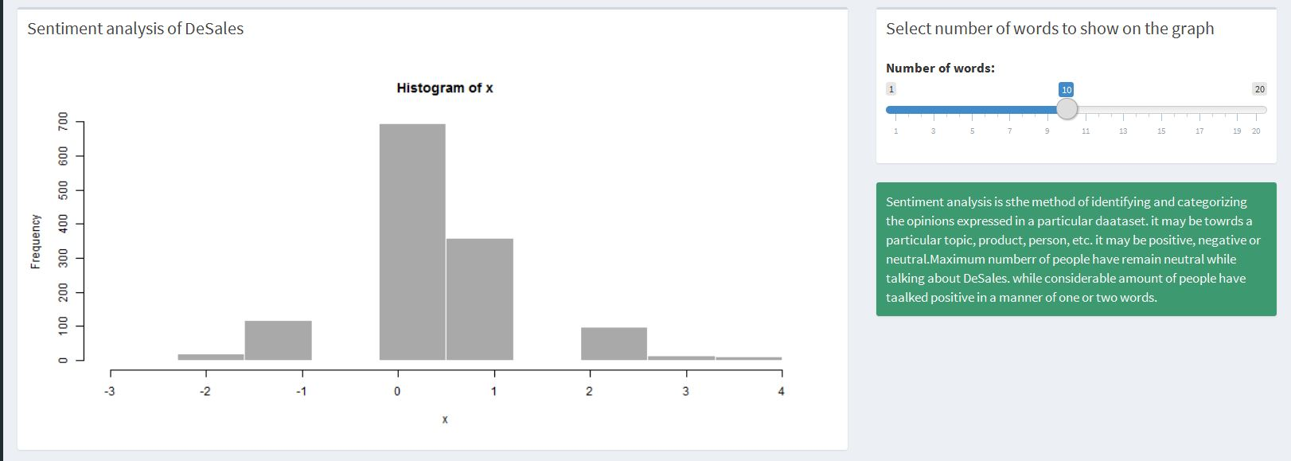

DeSales can use sentiment analysis on its Nuestra Voz monthly Spanish newspaper. By using sentiment analysis, DeSales would figure out the people's view on particular article in Nuestra Voz.

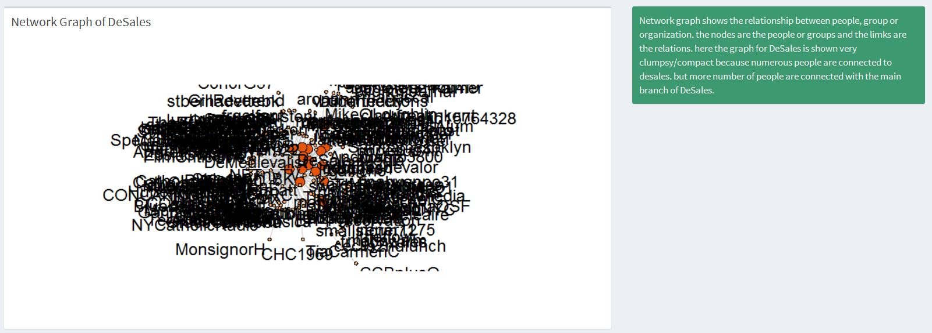

Network graph denotes the connections to the main model from the various clustures. The above image shows the relations to the Desales media from many set of clustures and the process is clumpsy because of the enormous input to the Desales media

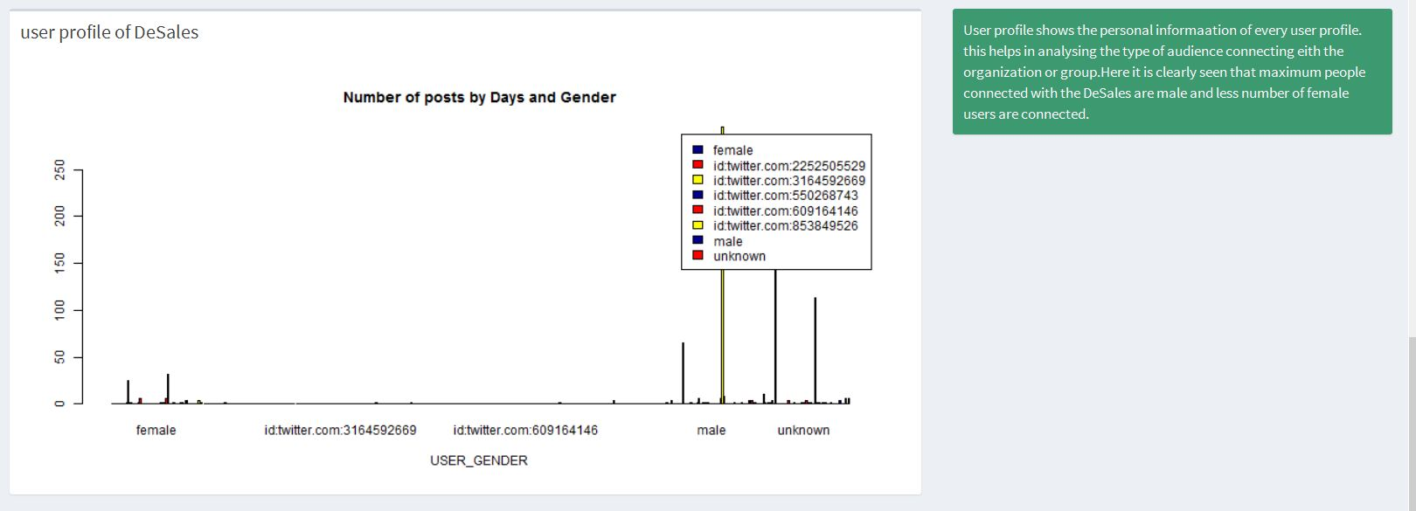

User profiles gives you the idea about every single user personal data who are connected to the process. The above graph represents the male and female comparison. X variant denotes the count of the male and female in Post and share. Post has the almost same number, and in share quantity of male is high.